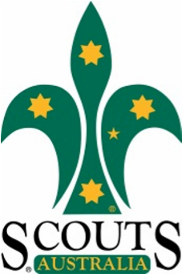
21st of July, 2016 – David Lockman
Neville Henderson OAM, Region Commissioner Greater Western Sydney advised of the passing of David Lockman.
David Lockman passed away on 19th July after a long illness. He joined scouts in 1998 as a Scout Leader at 1st Whalan and over the years has held a number of roles in Cumberland Gang Show and at the time of his passing was in the logistics team.
He attended three Jamborees at Cataract Scout Park as part of the Entertainment team. David joined Cumberland Gang Show Fellowship in 2007 and was still a current member at the time of his passing. We send our thoughts to his wife Valerie and the family.
To those who knew David Lockman, his Funeral service will be taking place 12:30PM Friday 29th July at The West Chapel, Pinegrove Cemetery.
As David wasn't a very formal person, we kindly ask that you please wear casual attire in his favourite colour, blue, or your Scout Uniform for members.
We also ask that instead of flowers a donation be placed in the box provided to be donated to his favourite charity, "Children's Medical Research". Afterwards we will be celebrating his life at Adele & Micheal's house. The address will be provided at the funeral service.

