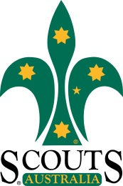
21st of July, 2016 – Mary Robinson
With great sadness, Sydney North Region has notified the passing of Mary Robinson early this morning.
Mary started her Scouting pathway at 1st Elanora Heights on the Group Committee in 1983 before starting her training as a Cub Leader.
Over 33 years, as well as Cub Leader, Mary held the positions of District Joey Leader, Region Leader (Joey Scouts), PLA, Assessor, District Commissioner Benowie and her last appointment has been Assistant District Commissioner Benowie. Mary will be remembered by many leaders as a much loved member of the training team.
Sydney North Region will be holding a Memorial Service for Mary Robinson on Thursday, 4th August 2016 at Hornsby RSL Club. Service will start at 4pm.
Members to wear full uniform and decorations.

