HOW TO REGISTER YOUR PROJECT

2018 NSW Community Building Partnership Grants
The steps to register for this grant are:
- Read the guidelines and make sure you are eligible to apply for the program. Guidelines are available by following the program link here: http://www.communitybuildingpartnership.nsw.gov.au
Online applications close at 5:00pm sharp Friday 27 September 2019.
- Register your project.
• Scroll down the page till you see:
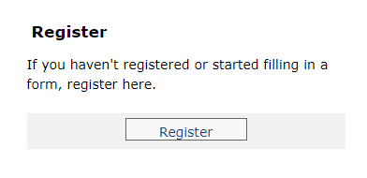
• Click on ‘Register’ to begin the submission.
• If you have a SmartyGrants registration, you can log in using those details; If you do not have a SmartyGrants registration, when registering, you will be asked to provide your name, the name of your organisation (use your local Scout Group), an email address and a password. The registration can be used to apply for a grant with any grant giving agency that is using SmartyGrants.
- Once you have registered your project you can login using your project login and password and complete the online application.
After completing the application you will submit it directly online, but you will be given the opportunity to create and print a PDF copy for your records. Please email a copy of your completed application as a .pdf to Cassandra Armstrong at CBPG@nsw.scouts.com.au
Please refer to the sample application provided by Scouts Australia NSW on this site to use as a guide for completing the application.
If you have questions, contact Cassandra Armstrong on 9735 9045 or by email CBPG@nsw.scouts.com.au
If you have any technical problems in completing this registration form please contact NSW Community Building Partnership office via phone on 13 77 88 or submit the online form at https://www.nsw.gov.au/improvingnsw/projects-and-initiatives/community-building-partnership/contact-community-building-partnership/
Good Luck with your applications!
Cassandra Armstrong
Grants Administrator
Scouts Australia NSW

