2019 NSW Community Building Partnership Grants
Sample Application
STOP! Have you read the Guidelines for Scout Groups and How to Register Your Project? If not, please read that document first. If so, please proceed through this document.
Ensure your project can be completed by 31 October 2021. Projects are unlikely to receive extensions past that date.
Remember – applications need to be submitted by 5pm 27 September 2019 in order to be eligible for the next round.
After you have registered your project, you will be able to complete the online application and submit it electronically through the following web site: http://www.communitybuildingpartnership.nsw.gov.au
Please use the following sample application as a guide only to assist you in completing the items in the application.
Notes and tips on how to complete the application will appear in red text or highlighted yellow.
If you have questions please contact Cassandra Armstrong, Grants Administrator on 02 9735 9045 or CBPG@nsw.scouts.com.au.
If you have any technical problems in completing this registration form please contact NSW Community Building Partnership office via phone on 02 8753 8144 or email at cbpinfo@facs.nsw.gov.au.
Copying or cutting and pasting from this document may prove difficult, so it is best to type directly into the online form.
Good Luck with your applications!
Cassandra Armstrong
Grants Administrator
Scouts Australia NSW

Community Building Partnership Program

Application Form
Question 1
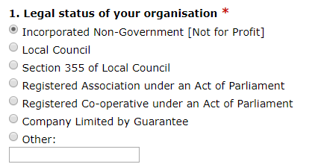
Question 2
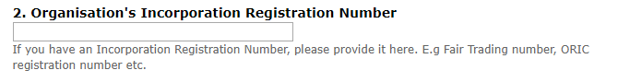
Leave blank
Question 3 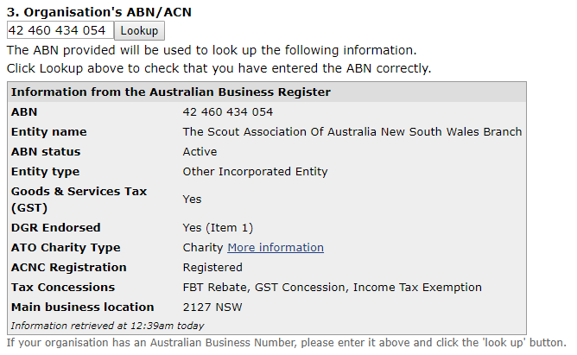
Question 4 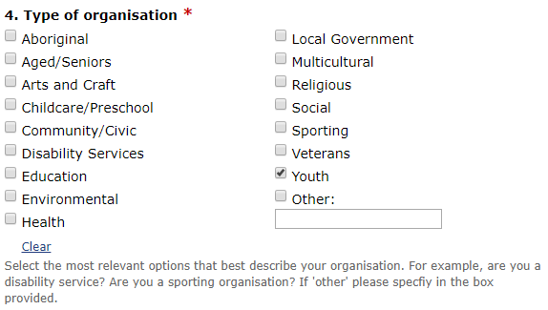
Question 5
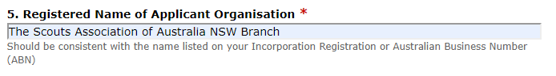
Question 6
Question 7
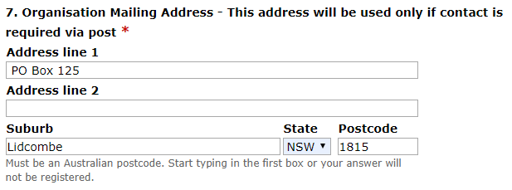

Question 8
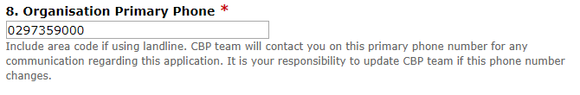
Question 9
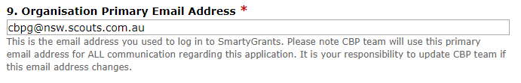
Question 10
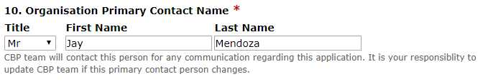
Question 11
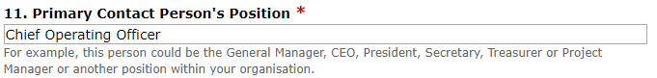
Question 12
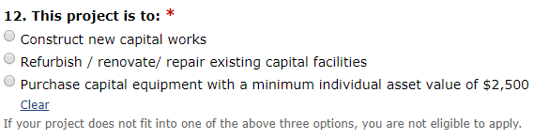
Select the best option
Question 13
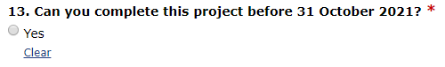
Ensure you can complete the project by this date
Question 14
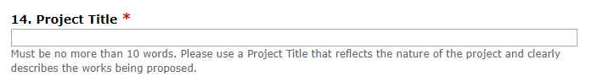
Enter the name of the project in under 10 words
Question 15
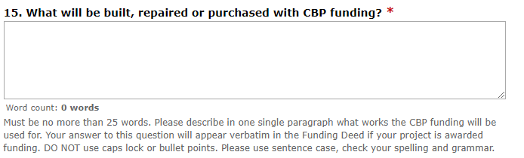
Enter the works that are going to be carried out.

Question 16
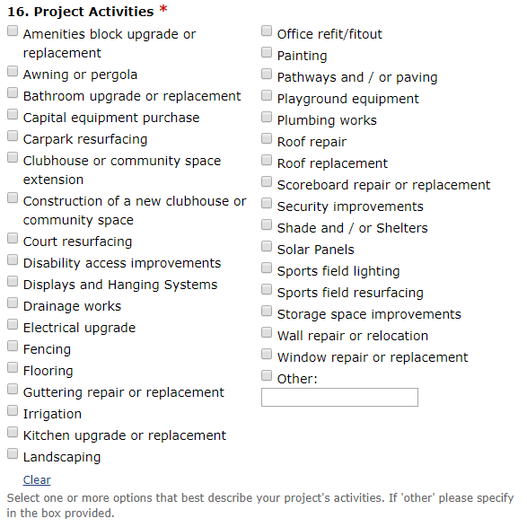
Select the activities of the project
Question 17
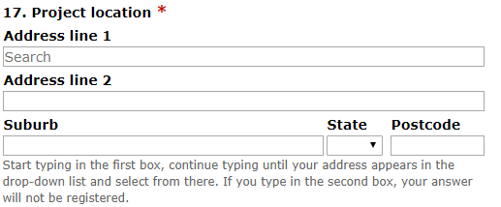
Enter the address of the project location
Question 18
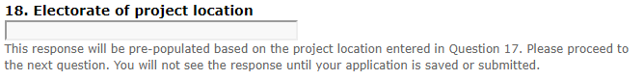
This response will be pre-populated based on the project location entered in Question 17.
Question 19
If your hall is in a park or oval, enter the name.
Question 20
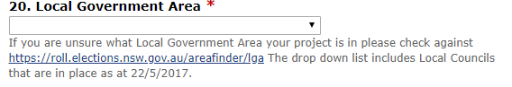
Select your local Council from the drop down list

Question 21
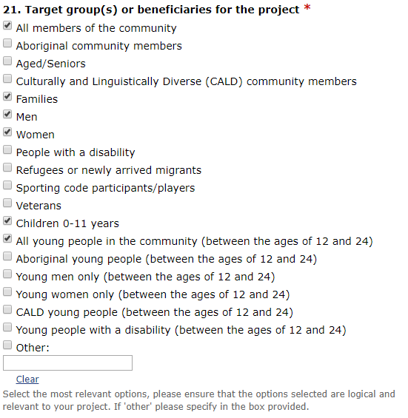
Question 22
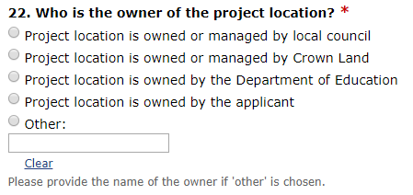
Our properties are most likely:
Or
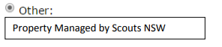
If you are unsure, please contact Cassandra Armstrong on 02 9735 9045
Question 23
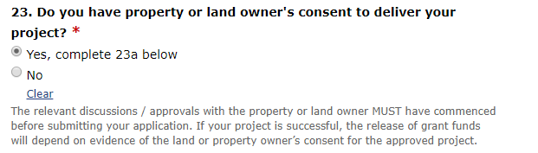
Question 23a
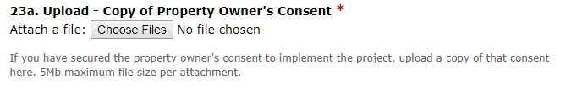
Upload the letter of Owners Consent from the template on the website
Question 24
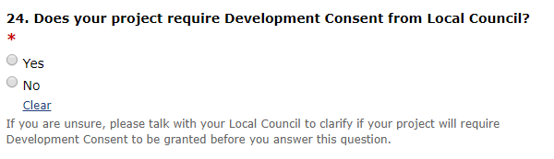
Select one option

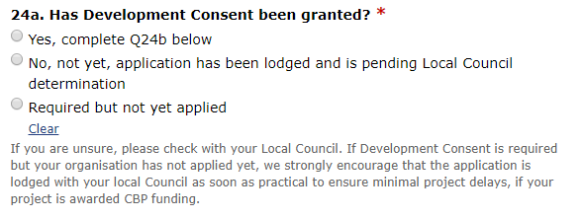
Question 24a
Skip if you
answered
no at 24

Select one option
Question 24b
Only upload if you said Yes at 24a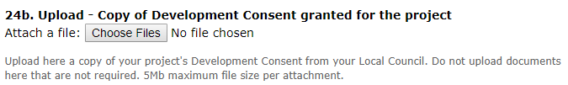
Upload your approved DA
Question 25
Upload the document found at http://www.nsw.scouts.com.au/leaders/insurance-information
Question 26
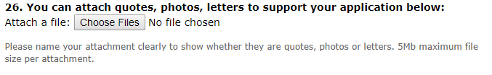
Add your quote(s)/Letters of support – these attachments will be highly regarded

Question 27
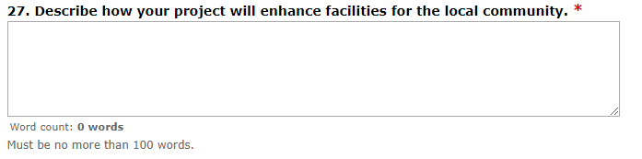
Answer the statement – see end of document for sample answer
Question 28
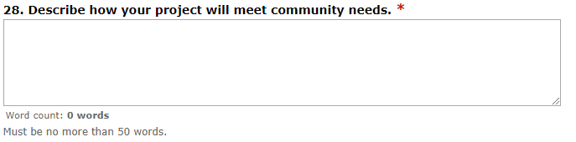
Answer the statement – see end of document for sample answer

Question 29
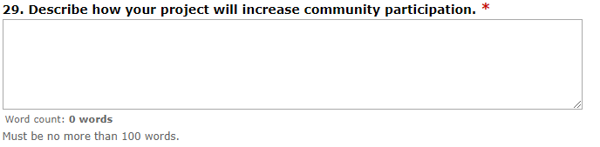
Answer the statement – see end of document for sample answer

Question 30
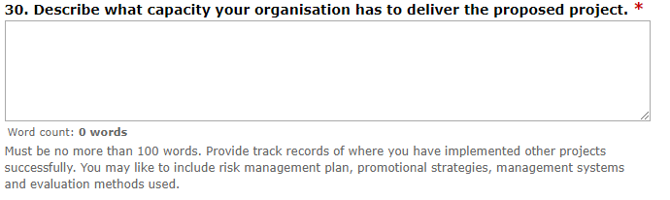
Answer the statement – see end of document for sample answer

Question 31
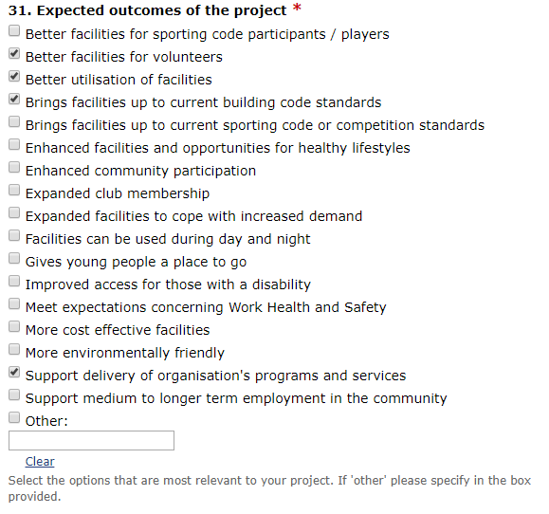

Select the most relevant options for your project

Question 32
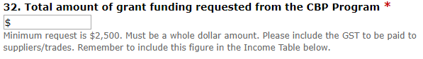

Question 33
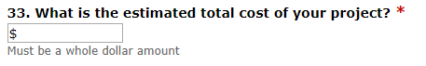

Question 34
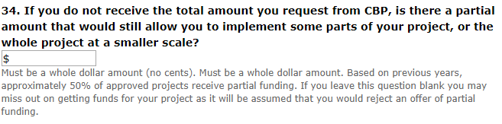

Question 35
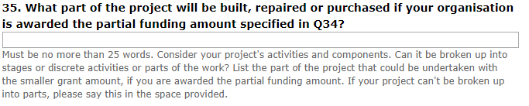

Question 36
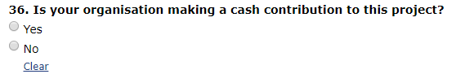
Cash contributions are not essential but are highly valued whenever possible.

Question 36a
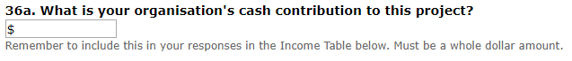

Question 37
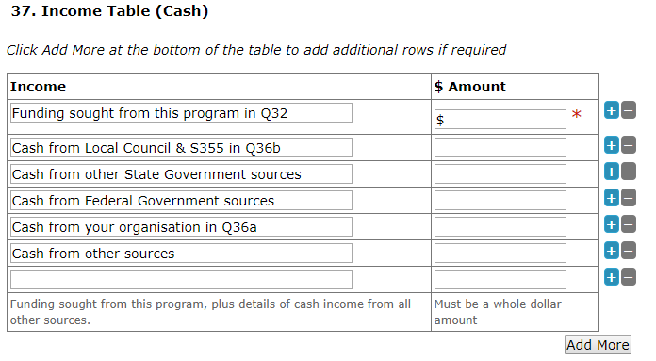

Answer as applicable

Question 38
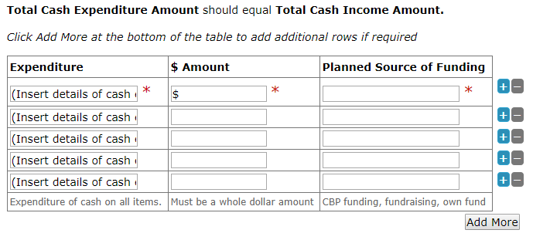

Answer as applicable

Question 39
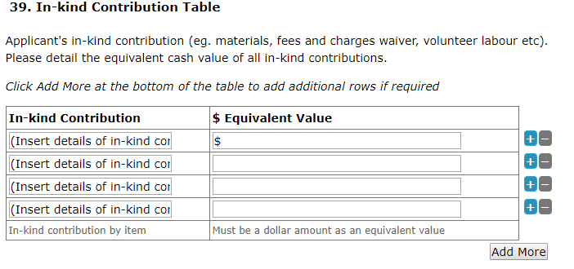

Include volunteer labour here at $43.06 an hour. This includes everything from working bees to project management.

Conflict of Interest
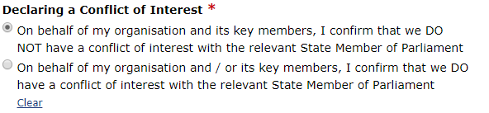

Unless someone in your group has a very close relationship (work or personal) with your State MP, answer that you do not have a conflict of interest
If someone in your groups DOES have a conflict of interest complete the following:
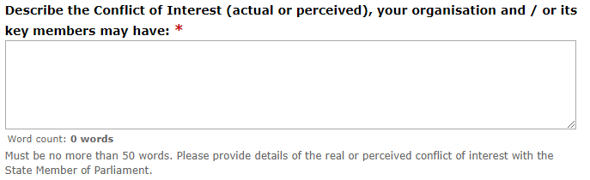

Application Checklist
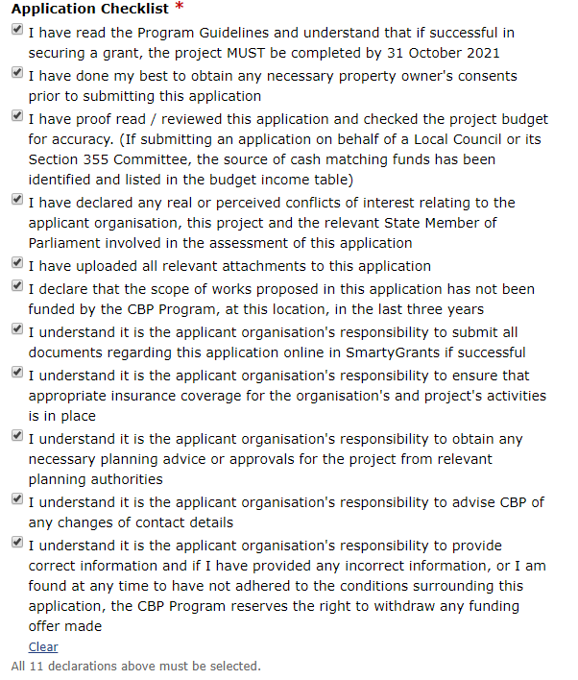

Read and tick all the boxes

Feedback
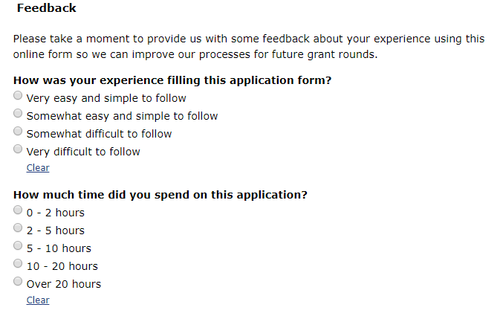
Provide feedback based on how you found the application

Applicant’s Declaration
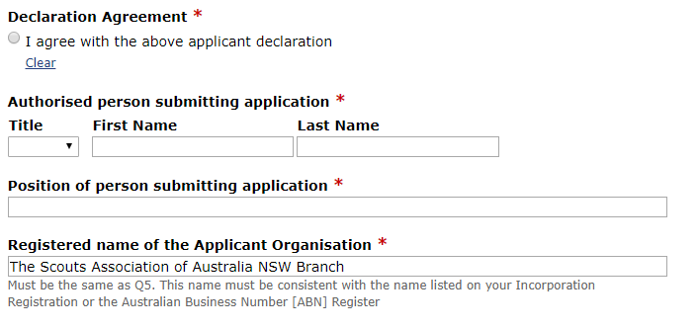
Complete with the name of the person submitting the application

Sample Answers
Question 27 | Describe how your project will enhance facilities for the local community – 100 words  Scouts are inclusive and welcome all community members helping young people build confidence, self-esteem, and leadership skills through outdoor recreation and educational activities. Scouts teach the importance of honesty, integrity and community service which are essential in improving local community cohesion.  This project at <Scout Group / Hall Name> will ensure Scouts and community members:  - Have access to safe, low cost facilities for meeting and recreational purposes  - Have the opportunity to participate in recreational and leadership activities  - Are able to access the programs offered by Scouts, regardless of gender, race, disabilities or financial circumstances.
Question 28 | Describe how your project will meet community needs – 50 words  This project at <Scout Hall> will:  - Ensure accessibility for all community members  - Eliminate barriers for participation in Scouting programs offered  - Upgrade our facilities to meet community expectations  - Increase hall-hire rate by community groups at low costs  - Allow us to continue providing high-quality affordable Scouting programs.
Question 29 | Describe how your project will increase community participation – 100 words  Key considerations for this question:  - What will the impact be if funding is not approved?  - Is the project required to ensure safety of participants (e.g. smoke alarms)  - Without this funding, can your Scout Group continue to grow? (e.g. if your hall only has male amenities, will the addition of female amenities enable more female participation?  - If you can, include relevant statistics or data that you have about your local community or region  ** Include information in response to these questions in your answer  Sample responses:  This project will allow us to accommodate more youth members in Scouts increasing the number of community members’ participation in our programs.  This project will raise the quality and standard of our hall and will encourage more community groups to hire our hall for their own purposes.  Our Activity Centre/Hall is regularly used by local members of the community. This project will increase the number of users we can accommodate at any given time and will encourage more people to utilise the facility.  Our Scout Group is in an area of high growth. Currently there are not enough community facilities to meet demand. This project will allow us to increase the amount of youths we can deliver Scouting activities to.
Question 30 | Describe what capacity your organisation has to deliver the proposed project – 100 words  Scouts Australia NSW has well developed governance systems in place. Our Branch Council appoints the Board of Directors comprised of 6 adult Scout members, the Treasurer, and 5 others with appropriate skills to support the strategic objectives. Our Association has a Constitution. At Region level, volunteer Property Managers oversee properties in their regions. They report through the Asset Committee (a sub-committee that reports to the Board) which include property professionals providing expertise and insight to projects.  At the local level, <insert Scout Group here> has extensive experience managing grants projects and acquitting them on time.

