29.1 WHS FORM - Workstation ergonomics self-assessment

Name of person being assessed: | Position:
Date:

The Workstation Ergonomics Self-Assessment is best undertaken in pairs. This enables one person to sit at their workstation while a second person observes and assists them achieve the recommended posture. Then move on to the other person’s workstation.

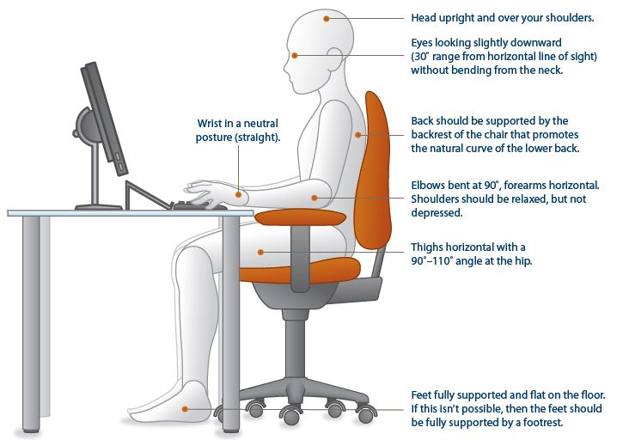

CHAIR | Yes | No | NA | Suggested actions
Can the height, seat and back of the chair be adjusted to achieve the posture outlined below? |  |  |  | - Obtain a fully adjustable chair
Are your feet fully supported by the floor when you are seated? |  |  |  | - Lower the chair  - Use a footrest
Does your chair provide support for your lower back? |  |  |  | - Adjust chair back  - Obtain adjustable chair  - Obtain lumbar roll
When you sit with your back against the back rest, is there a 2-3 finger width gap between the back of your knees, and the front of the seat? |  |  |  | - Adjust seat pan  - Add a back support  - Chair with smaller set pan
Armrests in general, are not recommended. However if you do have armrests, do they allow you to get close to your workstation? |  |  |  | - Adjust armrests  - Remove armrests

KEYBOARD & MOUSE | Yes | No | NA | Suggested Actions
Armrests in general, are not recommended. However if you do have armrests, do they allow you to get close to your workstation? |  |  |  | - Adjust armrests  - Remove armrests
Are your keyboard, mouse and work surface at your elbow height? |  |  |  | - Raise / lower workstation  - Raise or lower keyboard  - Raise or lower chair
Are frequently used items within easy reach? |  |  |  | - Rearrange workstation
Is the keyboard close to the front edge of the desk allowing space for the wrist to rest on the desk surface? |  |  |  | - Move keyboard to correct position
When using your keyboard and mouse, are your wrists straight and your upper arms relaxed? The keyboard should be flat and not propped up on keyboard legs as an angled keyboard may place the wrist in an awkward posture when keying. |  |  |  | - Re-check chair, raise or lower as needed  - Check posture  - Check keyboard and mouse height
Is your mouse at the same level and as close as possible to your keyboard? |  |  |  | - Move mouse closer to keyboard  - Obtain larger keyboard tray if necessary
Is the mouse comfortable to use? |  |  |  | - Rest your dominant hand by using the mouse with your non-dominant hand for brief periods (mouse buttons can be changed within the computer control panel)  - Investigate alternate mouse options.

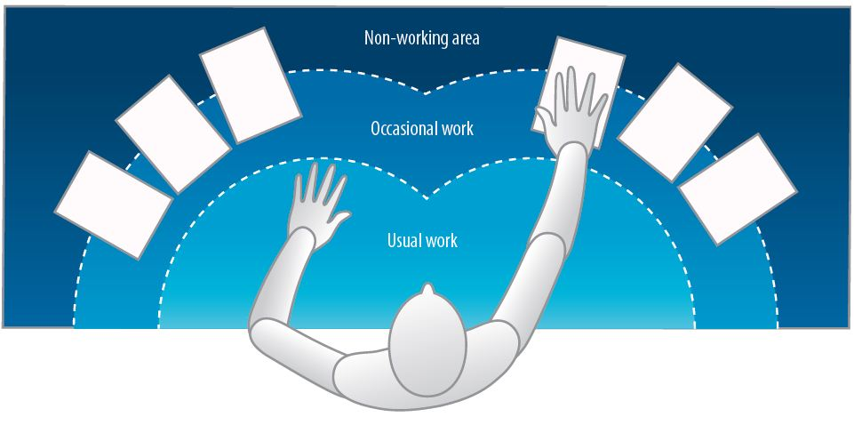
MONITOR & ACCESSORIES | Yes | No | NA | Suggested Actions
Is your monitor positioned directly in front of you? |  |  |  | - Reposition monitor
Is your monitor positioned at least an arm’s length away?  Note: the monitor’s location is dependent on the size of the monitor, the font, screen resolution and the individual user e.g. vision/use of bifocal spectacles etc. |  |  |  | - Reposition monitor  - Seek an alternative monitor if necessary e.g. flat screen that uses less space
Is your monitor height slightly below eye level? |  |  |  | - Add or remove monitor stand  - Adjust monitor height
Is your monitor and work surface free from glare? |  |  |  | - Windows at side of monitor  - Adjust overhead lighting  - Cover windows  - Obtain antiglare screen
Do you have appropriate light for reading or writing documents? |  |  |  | - Obtain desk lamp  - Place on left if right-handed – place on right if left handed
Are frequently used items located within the usual work area and items which are only used occasionally in the occasional work area? |  |  |  | - Rearrange workstation
Is there a sloped desk surface or angle board for reading and writing tasks if required? |  |  |  | - Obtain an angle board
Is there a document holder either beside the screen or between the screen and keyboard if required? |  |  |  | - Obtain document holder
Are you using a headset or speakerphone if you are writing or keying while talking on the phone? |  |  |  | - Obtain a headset if using the phone and keyboard
BREAKS | Yes | No | NA | Suggested Actions
Do you take postural breaks every 30 minutes? E.g. standing, walking to printer / fax etc.? |  |  |  | - Set reminders to take breaks
Do you take regular eye breaks from looking at your monitor? |  |  |  | - Refocus on picture on wall every 30 minutes
LAPTOP | Yes | No | NA | Suggested Actions
In the event of using a laptop computer for prolonged periods of time use of;  - A full sized external keyboard and mouse;  Docking station with full sized monitor or a laptop stand |  |  |  | Obtain appropriate laptop accessories
“Hot Desking” (when applicable) | Yes | No | NA | Suggested Actions
Provided time, support and supervision to make above adjustments.

Following completion of this checklist, please discuss any concerns or requirements with your manager.
In some cases, using non-standard equipment can cause injury. You may be required to submit a letter from your treating doctor tin order to provide specific ergonomic equipment.

